Directions: The goal of the following problems is to help challenge and deepen your understanding of the current topic. Don’t assume that you will know how to answer each and every question. You will work with at least two other students in the class to try and find solutions and write arguments for each of the following questions. Be sure that you question your classmates’ reasoning. If you don’t understand how they are getting something you should ASK THEM TO EXPLAIN! Being able to defend your reasoning is important and so you are actually helping them by asking them to explain.

Challenge Questions
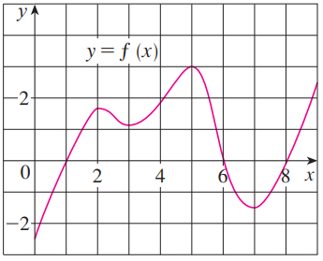
- The graph of a function is shown at the right. Assume that the domain of is . Use the graph of the function to help answer the following questions.
- On what intervals is f increasing? Decreasing?
- At what values of x does f have a local maximum? Local minimum?
- Estimate on what intervals is f concave upward? Concave downward?
- Estimate the x-coordinate(s) of the point(s) of inflection.

- Consider the function . Without the use of a graph, determine each of the following.
- On what intervals is f increasing? Decreasing?
- At what values of x does f have a local maximum? Local minimum?
- On what intervals is f concave upward? Concave downward?
- State the x-coordinate(s) of the point(s) of inflection.

- Suppose the derivative of a function is .
- Determine where is increasing and decreasing, if you assume that is defined on .
- Determine at what x-values has local extrema.

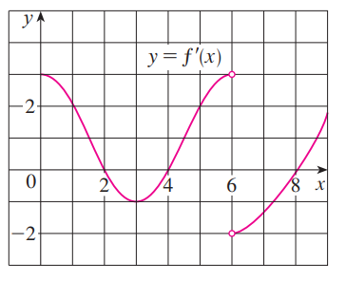
- The graph of the derivative of is shown below.
- On what intervals is f increasing? Decreasing?
- At what values of x does f have a local maximum? Local minimum?
- On what intervals is f concave upward? Concave downward?
- State the x-coordinate(s) of the point(s) of inflection.
- Use the information that you have to create a possible picture of .

- Find the local maximum and minimum values of using both the First and Second Derivative Tests.

- Suppose that , , and and for all x.
- Sketch a possible graph for f.
- How many solutions does the equation have? Why?
- Is it possible that ?

- Consider the function .
- Determine the exact value of x at which increases most rapidly. Hint: Something is being maximized here. What function are we trying to maximize?
- Reflect on your work in part (a). What does your work here imply about the significance of inflection points?

- Consider the function , where a, b, c, & d are real numbers with .
- Prove that has exactly one inflection point.
- Prove that if has 3 x-intercepts, then the inflection point occurs at the average value of the intercepts.
- Use the result to from part (b) to find the inflection point of the cubic polynomial , and check your result by finding the inflection points of using the second derivative.

- For what value c is the function increasing on .

